nRF24L01plus_remote_control_servo_ESC

Example sketch for using nRF24L01+ radios to act as a RC transmitter and receiver for controlling a servo or ESC.

Sorry these aren’t the clean diagram - I hope to improve the documentation as I develop the code.

# Project docs and code here:

https://github.com/JustinSK/Arduino-Remote-Control

# Potentiometer with Transmitter Setup.

Potentiometer using 5v, Negative and A0.

# Transceiver nRF24L01+ chip pin instructions here:

<http://howtomechatronics.com/tutorials/arduino/arduino-wireless-communication-nrf24l01-tutorial/> . Note the Arduino pin locations vary based upon the Arduino board you use. Just search for the corresponding pin diagram for your board, i.e. “Arduino Uno Pin Diagram”.

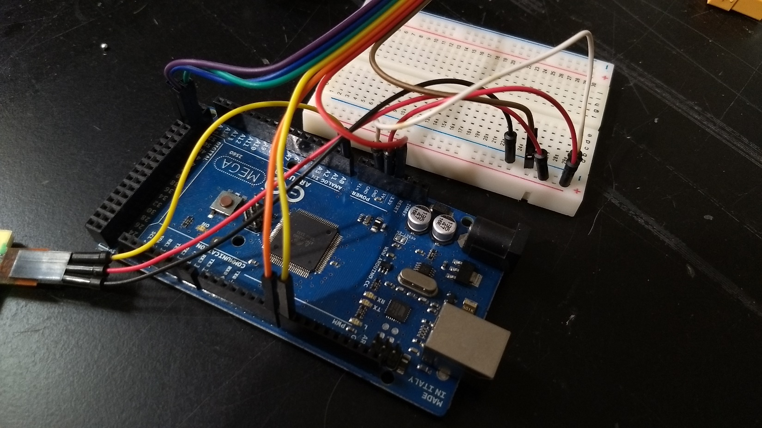

# nRF24L01+ Wireless Receiver board with Servo / ESC

Servo using +5V, negative and D9. Servo / ESC connector circled. nRF24L01+ setup same as above.

